Site navigations: link the top image with the homepage
The rating should be in all the sections
For the referencing use the APA format

- Dyslexia section: set it as a homepage
Please make an infographic about the Dyslexia to aware the society
Add the following sections
What Dyslexia Is
Dyslexia Signs and Symptoms
How Dyslexia Is Diagnosed ; the test (create quiz to show the result using questions from this site : https://www.testdyslexia.com/ this site has 7 kinds of tests levels)
Possible Causes of Dyslexia

- About Us:
The name of the site should be “Dyslexia Land” and change the name even in the footer section which is about the site copywrite
You are using different names (Dyslexia and technology + Dyslexia&me ) is each sections which confusing.
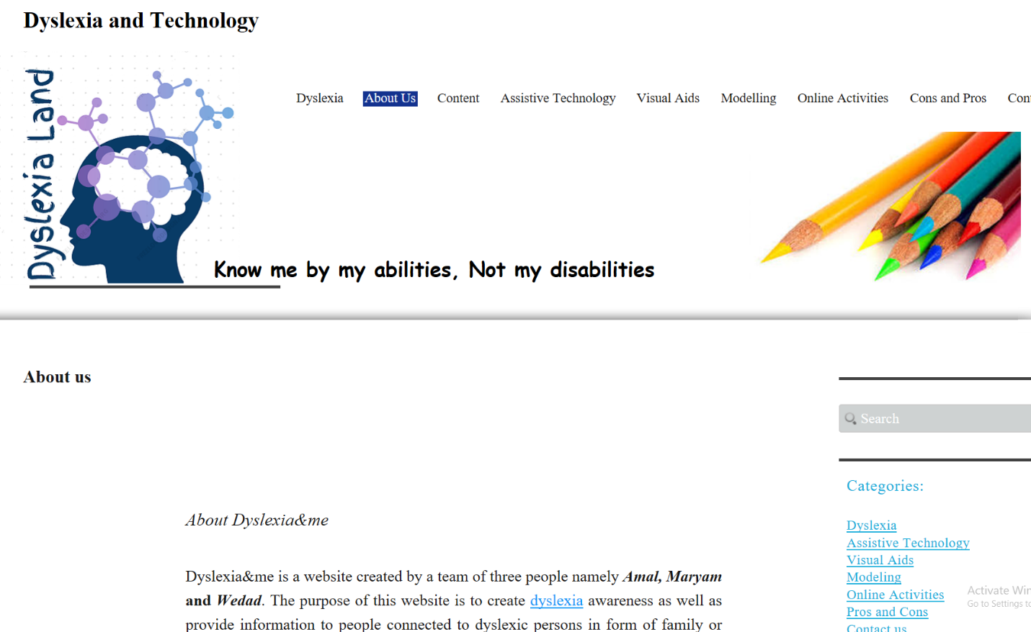
- Modelling
Kinds of Video Models: please add video for each type
Steps for Teaching dyslexic Learners how to read
- Online Activities
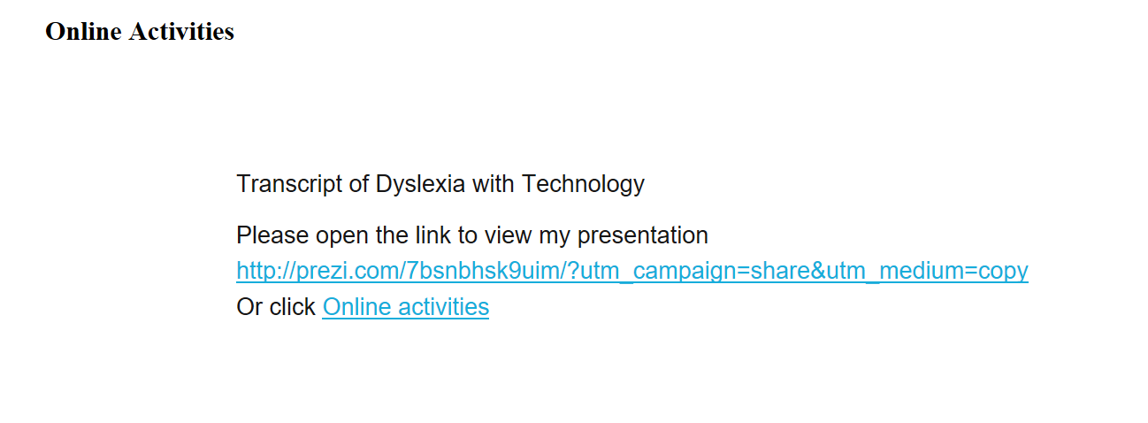
The content of this section is copied from the example site
Please make a prizi for dyslexia, and please make the account under the name of Amal
Games should be suitable for dyslexia children as well as the videos

- Contact Us
Contact Form to send to my email: 200106763@hbmsu.ac.ae

